LEOI-50 semiconductor pump laser principle experimental device

Instruction Manual

Idealphotonics Technology (Hongkong) Technology Co.,LTD

Contents
I. Experimental Instruments 3
II. Installation 3
III. Experimental purpose and significance 3
IV. Experimental principle 4
V. Experimental equipment 6
VI. Operation steps 7
VII. Precautions 8

I. Experimental Instruments
1. 808nm semiconductor laser less than 500mW
2. Semiconductor laser adjustable power supply current 0 ~ 500mA
3. Nd:YVO₄ crystal 3 * 3 * 1mm
4. KTP frequency doubling crystal 2 * 2 * 5mm
5. Output mirror (front cavity) φ6 R=50mm
6. Optical power indicator 2 W to 6 200mW.

II. Installation
1. Unpacking
After opening the packaging of the instrument, please check in accordance with the packing list. If you find that it doesn’t match with the packing list or the instrument surface has obvious damage, please contact the seller immediately.
2. Installation site
The device is a laboratory instrument. In order to improve the quality and prolong the service life of the instrument, the following notice should be paid attention to when selecting the instrument installation site:
1. Ambient temperature range is 20±5℃
2. Purify humidity is less than 65%
3. Strong vibration source or strong electromagnetic interference is not allowed.
4. Clean and no corrosive gas in the room.
5. The instrument should be placed on a hardened platform.
6. Not to be exposed to sunlight for a long time.
7. The room should be provided with a voltage stabilizing power supply which supplies power to the instrument and ground electrode to ensure the good grounding of the instrument.

3. Installation method
The semiconductor pumping laser LEOI-50is a precision laboratory instrument whose installation site should be meet the requirements in 2.2. The worktable must be steady. The wiring diagram of the system is shown in figure (the connection plug of each part is unique, so the connection error will not occur):

III. Experimental purpose and significance
The semiconductor pumped 0.53 um green laser has a short wavelength and high photon energy, it can transmit so far in the water and is sensitive to human eyes. It has many features, such as long operating life, small size, good efficiency and reliability. In recent years, the extremely important application has shown in the field of spectroscopy technology, Laser medicine, information storage, color printing, underwater communication, laser technology and many other parts of the national economy and it has become the focus of research in various countries.
The Semiconductor pumped 0.53um green laser is suitable for the experiment of nonlinear optics in modern physics college teaching. The experiment takes 808nm semiconductor pumped Nd:YVO₄ laser as the research object, it allows students to adjust the light ,inserted the excitation KTP crystal into the cavity to generate 532nm frequency doubling laser. By observing the frequency doubling phenomenon and measuring the threshold value, phase matching and other basic parameters, students can have a good understanding of laser technology.

IV. Experimental principle
The interaction of light and matter can be attributed to the interaction of light and atoms. There are three processes: absorption and spontaneity radiation and stimulated radiation.
Without external photons, an atom in the ground state remains unchanged. if a photon whose energy is hv₂₁ approaches, it absorbs the photon and jump to the excited state E2. In the process, not all the photon can be absorbed by an atom. Only the energy of the photon is equal to the energy interval of the atom E1-E2 can be absorbed.
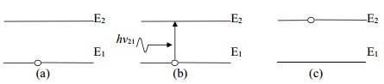
The absorption process of light
Excited states have very short lifetimes, and they will spontaneously return to the ground state and emit photons without any external influences. The spontaneous radiation process has nothing to do with the external effects. Because the radiation of each atom is spontaneous and independent, the emission direction and initial phase of the photon emitted by different atoms are different.
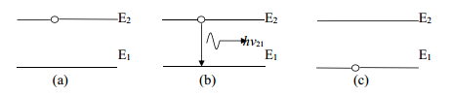
The spontaneous radiation process of light
The excited atom is shifted to the lower energy state under the influence of the external photon, and the energy difference between the two states is transformed by emitting a radiation photon. Only the external photon energy is equal to the excited state and ground state energy level, can be caused by stimulated emission of radiation, and stimulated radiation emitted photons and the external photon emission direction, frequency, polarization and phase is the same. The generation of laser mainly depends on stimulated radiation.
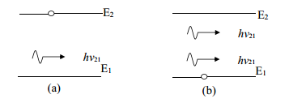
The stimulated radiation process of light
The laser is mainly composed of working material, resonator and pump source. The working material mainly provides the number of particles inversion.
The pump process draws the particles from the ground state E1 to the excited state E3, and the particles on the E3 rapidly shifts to metastable state E2 pass through the non-radiative transition,
in which part the particle transition from high energy level to low energy level, the energy changes into thermal energy or lattice vibrational energy, but not radiation photon. E2 is a long-lived energy level, so that the particles on the E2 accumulate continuously, and the particles on the E1 are reduced by the pumping process, so that the particle number inversion between the E2 and the E1 levels is achieved.
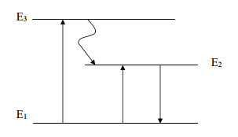
Three - level system diagram
The generation of Laser requires a resonant cavity that provides optical positive feedback. Particles in an excited state are unstable due to instability Spontaneous radiation to the ground state, spontaneous radiation of photons generated in all directions, the deviation from the axial photon will escape out of the cavity soon, Only along the axis of the photon, between the two mirrors, is magnified several times to form a light amplification of the stimulated radiation, which produces a laser. Part of these output through the output mirror, the part is reflected back to the working material.

Optical frequency doubling
The optical frequency doubling is one of the most commonly nonlinear optical methods for extended band. With the nonlinear property of crystals, Laser frequency doubling can make the light whose frequency is ω produce a frequency of 2ω.
When the light interacts with the material, the atoms in the substance will produce an electric dipole moment due to induction. The inductance dipole moments within the unit volume are superimposed to form an electrostiac intensity vector. The polarization field generated by the polarization field emits secondary electromagnetic radiation. When the electric field intensity of the applied field is much smaller than that of the atomic field, the electrode intensity induced by the material is proportional to the intensity of the external electric field.
$$P= ε_{0}×E$$
Before the laser appears, when there are several different frequencies light within the material at the same time, the various frequencies of light are linearly independent reflection, refraction and scattering, to meet the wave superposition principle, it does not produce a new frequency.
When the electric field intensity of the external field is large enough (such as laser), the response of the material to the light field has a non-linear relationship with the field strength:
$$P=αE+βE^{2}+γE^{3}+…$$
The parameters of$α$,$β, γ$are all matter dependent coefficients, and decrease progressively, and the relation of their order of magnitude is
$$\frac{β}{α}=\frac{γ}{β}=…=\frac{1}{E_{atom}}$$
The E atom is an electric field in the atom, whose magnitude is 108V/cm, and the nonlinear terms such as E2 and E3 in the upper formula are small and negligible. If the E is large, the nonlinear term cannot be neglected.
Consider the square term of an electric field
$$E=E_{0}cosωt$$
$$P^{(2)}=βE^{2}=βE_{0}^{2}\cos^{2}ωt=β\frac{E_{0}^{2}}{2}(1+cos2ωt)$$
The DC term and the frequency doubling term $cos2ωt$ appears, the DC term is called the optical rectification. When the laser strikes the optical frequency doubling crystal at a certain angle, the frequency doubled light is generated in the crystal, and the incident angle of the double frequency light is called a supporting role.
The conversion efficiency of frequency doubled light is the intensity ratio of the frequency doubled light to the fundamental frequency light, which can be obtained by nonlinear optical theory:
$$η=\frac{I_{2ω}}{I_{ω}}∝βL^{2}I_{ω}\frac{\sin^{2}(∆kl/2)}{(∆kl/2)}$$
Where L is the length of crystal, $I_{ω}$ and $I_{2ω}$ respectively for the fundamental frequency input light intensity and the output frequency doubled light. $∆k=k_{ω}-2k_{2ω}$is respective to propagation vector of fundamental frequency light and frequency doubled light.
In the normal dispersion condition, the refractive index ratio of frequency doubled light $n_{2ω}$ is bigger than the fundamental frequency light, so the phase mismatch. The refraction of o light and e light in birefringent crystal is different, and the e-light refractive index changes with the propagation direction and the angle between the optical axis. The refraction difference among o-light and e-light in birefringent crystal can be used to compensate medium normal dispersion of different wavelength to the phase matching.

V. Experimental equipment
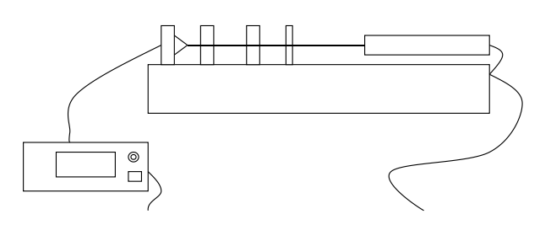
Power supply wiring diagram
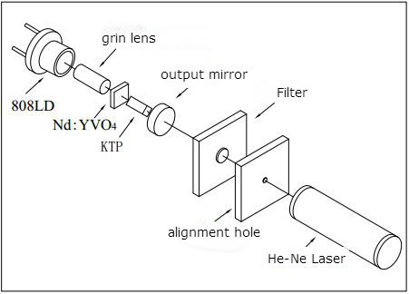
1.064 m near-infrared laser is pumped by 808nm LD and after intracavity frequency doubling in KTP crystal, the 0.53nm green laser generates. Nd:YVO₄ ,whose size is 3 x 3 x 1mm doping concentration of 3at% and$α-cut$, severs as working medium. About 95% incident light is absorbed, choose 2 * 2 * 5mm phase matching KTP as the frequency doubling crystal. The pass surface has high transmittance to 1.064 um and 0.53um.in order to improve Using the end pump to improve the efficiency of space coupling, with a focal length of 3mm gradient refractive index lens to collect 808LD laser focused into 0.1μm fine beam, so that the light beam in the Nd: YVO4 crystal. The resonant cavity for the concave, the back sheet is heated and bent. Output mirror (front cavity) chooses K9 glass that R is 50mm, high anti for 808.5nm, 1.064um and penetration for 0.53 um. 632.8nm He-Ne laser is used for collimating light source

VI. Operation steps
Laser optical path adjustment
1. Fixed 808nmLD on the two-dimensional frame, then make He-Ne 632.8nm red light through the white hole into the refractive index gradient lens. Adjust He-Ne 632.8nm light and small holes and 808nmLD on the same axis.
2. The Nd: YVO4 crystal is mounted on a two-dimensional frame, make red light passes through the crystal and the returned spot passes through the aperture.
3. The output mirror (front cavity) is fixed on the four-dimensional frame. Adjust the output mirror to make sure the returned spot passes through the hole. For a certain curvature of the output mirror, there will be a few spots , the spots back from the center should be distinguished.
4. Insert the KTP multiplier crystal between the Nd: YVO4 crystal and the output mirror, turn on the power and adjust the multi-turn potentiometer.
5. Produce 532nm times the green laser. Adjust the output mirror and LD adjustment frame to generate the maximum power of 532nm green.

VII. Precautions
1. In the experiment, the laser output has high energy and large power density. So it should be avoided direct to the eyes. Especially 532nm green light, do not look directly at the laser axial output beam, for avoiding permanent damage to the retina.
2. To avoid contact with the laser output mirror, the crystal coating surface, the film should be anti-moisture. Crystal and the output cavity should be wrapped with a lens paper and placed in the dryer.
3. If finding that the crystal and the output mirror is dirty during the adjustment, the available mixture (alcohol and ether 4: 1) paint test.
4. Laser should pay attention to the switch step, first check whether the multi-turn potentiometer is at the minimum or not, and then turn on the power switch, adjust the potentiometer to increase the current gradually and generate the laser. After the experiment is completed, adjust the potentiometer to make sure the current is zero, and finally turn off the power.

LEOI-50semiconductor pump laser principle experiment device packing list
1 | Optical guide and base | 1
2 | Two dimensional adjusting frame | 2
3 | Four-dimensional regulating frame | 2
4 | Collimation He-Ne laser frame | 1
5 | Pumping source: 808nm semiconductor laser | 1
6 | Indicating source: 632.8nmHe-Ne laser | 1
7 | KTP crystal | 1
8 | Nd:YVO4 crystal | 1
9 | Output mirror | 1
10 | Filter | 1
11 | Collimating hole (light target) | 1
12 | Optical power indicator | 1
13 | Power cord | 2
14 | Infrared Viewing card | 1
15 | Instruction manual | 1
16 | Product qualification certificate | 1
17 | Packing list | 1
18 | Optical power probe slide | 1

